There are a total of n courses you have to take, labeled from 0 to n-1.

Some courses may have direct prerequisites, for example, to take course 0 you have first to take course 1, which is expressed as a pair: [1,0]

Given the total number of courses n, a list of direct prerequisite **pairs** and a list of queries **pairs**.

You should answer for each queries[i] whether the course queries[i][0] is a prerequisite of the course queries[i][1] or not.

Return *a list of boolean*, the answers to the given queries.

Please note that if course **a** is a prerequisite of course **b** and course **b** is a prerequisite of course **c**, then, course **a** is a prerequisite of course **c**.

**Example 1:**

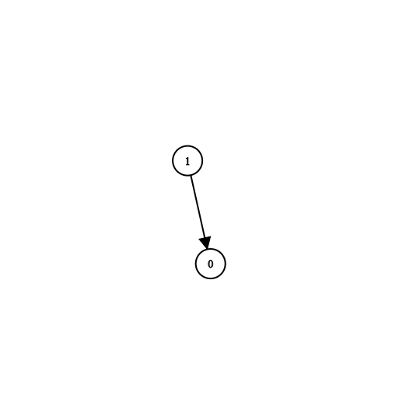

**Input:** n = 2, prerequisites = [[1,0]], queries = [[0,1],[1,0]]

**Output:** [false,true]

**Explanation:** course 0 is not a prerequisite of course 1 but the opposite is true.

**Example 2:**

**Input:** n = 2, prerequisites = [], queries = [[1,0],[0,1]]

**Output:** [false,false]

**Explanation:** There are no prerequisites and each course is independent.

**Example 3:**

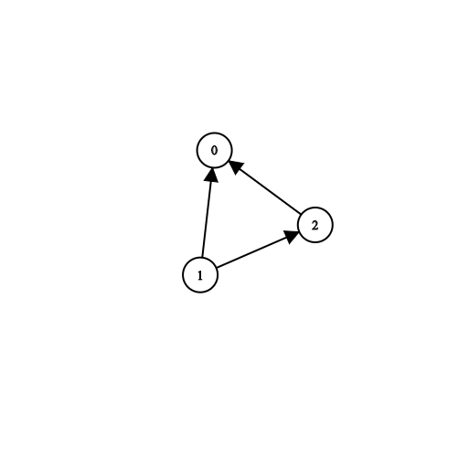

**Input:** n = 3, prerequisites = [[1,2],[1,0],[2,0]], queries = [[1,0],[1,2]]

**Output:** [true,true]

**Example 4:**

**Input:** n = 3, prerequisites = [[1,0],[2,0]], queries = [[0,1],[2,0]]

**Output:** [false,true]

**Example 5:**

**Input:** n = 5, prerequisites = [[0,1],[1,2],[2,3],[3,4]], queries = [[0,4],[4,0],[1,3],[3,0]]

**Output:** [true,false,true,false]

**Constraints:**

* 2 <= n <= 100
* 0 <= prerequisite.length <= (n * (n - 1) / 2)
* 0 <= prerequisite[i][0], prerequisite[i][1] < n
* prerequisite[i][0] != prerequisite[i][1]
* The prerequisites graph has no cycles.
* The prerequisites graph has no repeated edges.
* 1 <= queries.length <= 10^4
* queries[i][0] != queries[i][1]